**GRAPHICAL REPRESENTATION OF DATA IN SPSS**

**Assignment Number 2**

Register Number: 1740256

**Date:** 20/11/2017

--------------------------------------------------------------------------------------------

**Question 1**

**Aim –**To demonstrate graphical representation using bar chart in SPSS for carpet.sav data set

**Procedure –**

1. Open SPSS and choose any data file.
2. Go to graphs and click on chart builder.
3. Click ok on the dialogue box.
4. Choose any variable by dragging and dropping in the space provided.
5. Choose the appropriate graph and click on its image in the lower part of the window.
6. We observe that this graph is now displayed in the top portion of the window.
7. Choose the appropriate variable from the left-hand list and drag drop it to the chart [x-axis or y-axis]
8. Click ok and we see that the bar chart for the selected data appears in a new window.

**Calculations –**

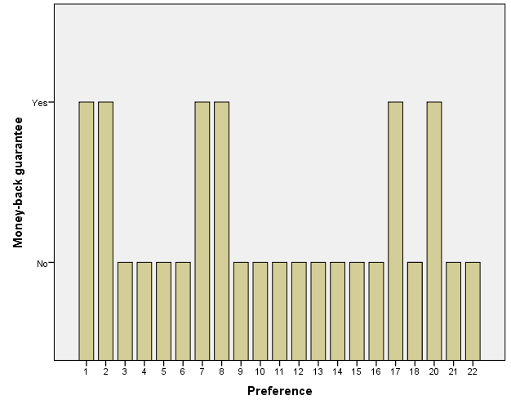

**Conclusions –**

The above graph shows the bar chart for carpet.sav in preference and money – back guarantee.

**Question 2**

**Aim –** To demonstrate graphical representation using bar chart in SPSS for accidents.sav data set

**Procedure –**

1. Open SPSS and choose any data file.
2. Go to graphs and click on chart builder.
3. Click ok on the dialogue box.
4. Choose any variable by dragging and dropping in the space provided.
5. Choose the appropriate graph and click on its image in the lower part of the window.
6. We observe that this graph is now displayed in the top portion of the window.
7. Choose the appropriate variable from the left-hand list and drag drop it to the chart [x-axis or y-axis]
8. Click ok and we see that the bar chart for the selected data appears in a new window.

**Calculations –**

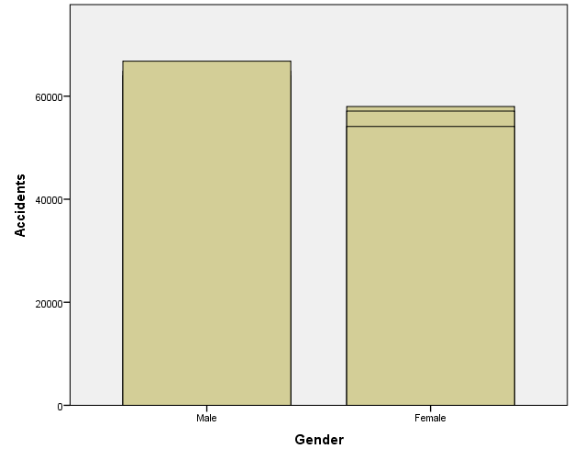

**Conclusions –**

The above graph shows the bar chart for accidents.sav with the number of accidents and gender.   
--------------------------------------------------------------------------------------------

**Question 3**

**Aim –** To demonstrate graphical representation using subdivided bar chart in SPSS for aflatoxin.sav data set

**Procedure –**

1. Open SPSS and choose any data file.
2. Go to graphs and click on chart builder.
3. Click ok on the dialogue box.
4. Choose any variable by dragging and dropping in the space provided.
5. Choose the appropriate graph and click on its image in the lower part of the window.
6. We observe that this graph is now displayed in the top portion of the window.
7. Choose the appropriate variable from the left-hand list and drag drop it to the chart [x-axis or y-axis]
8. Click ok and we see that the bar chart for the selected data appears in a new window.

**Calculations –**

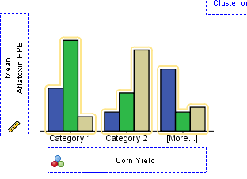

**Conclusions –**

The above graph shows the subdivided bar chart for aflatoxin.sav with the mean of aflatoxin and corn yield.

--------------------------------------------------------------------------------------------

**Question 4**

**Aim –** To demonstrate graphical representation using multiple bar chart in SPSS for aflatoxin.sav data set

**Procedure –**

1. Open SPSS and choose any data file.
2. Go to graphs and click on chart builder.
3. Click ok on the dialogue box.
4. Choose any variable by dragging and dropping in the space provided.
5. Choose the appropriate graph and click on its image in the lower part of the window.
6. We observe that this graph is now displayed in the top portion of the window.
7. Choose the appropriate variable from the left-hand list and drag drop it to the chart [x-axis or y-axis]
8. Click ok and we see that the bar chart for the selected data appears in a new window.

**Calculations –**

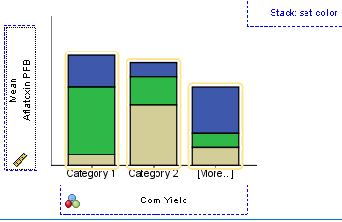

**Conclusions –**

The above graph shows the multiple bar chart for aflatoxin.sav with the mean of aflatoxin and corn yield.

--------------------------------------------------------------------------------------------

**Question 5**

**Aim –** To demonstrate graphical representation using pie chart in SPSS for aflatoxin.sav data set

**Procedure –**

1. Open SPSS and choose any data file.
2. Go to graphs and click on chart builder.
3. Click ok on the dialogue box.
4. Choose any variable by dragging and dropping in the space provided.
5. Choose the appropriate graph and click on its image in the lower part of the window.
6. We observe that this graph is now displayed in the top portion of the window.
7. Choose the appropriate variable from the left-hand list and drag drop it to the chart [x-axis or y-axis]
8. Click ok and we see that the bar chart for the selected data appears in a new window.

**Calculations –**

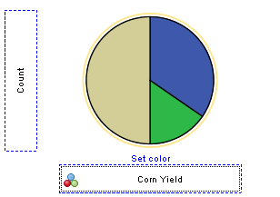

**Conclusions –**

The above graph shows the pie chart for aflatoxin.sav with the count of aflatoxin and corn yield.

--------------------------------------------------------------------------------------------